Evans and Zelnik perform at library
Published Aug 21, 2013 at 1:12 pm (Updated Aug 21, 2013)

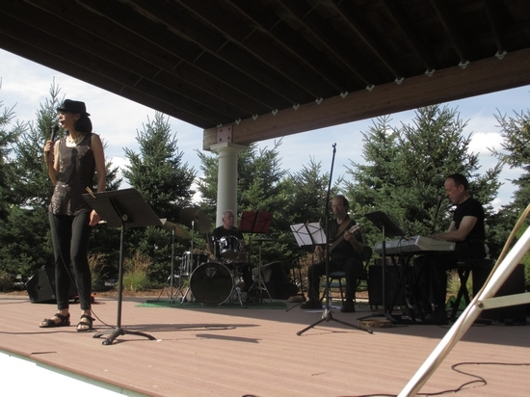
Photo by Viktoria-Leigh Wagner Fancine Evans, at right, sings as John Arbo plays guitar, David Cox drums and Joel Zelnik plays on the keyboard Saturday at the Sussex-Wantage branch of the Sussex County Public Library in Wantage
By Viktoria-Leigh Wagner
WANTAGE — Musical duo Francine Evans and Joel Zelnik appeared at the Sussex-Wantage Library Aug.17th, to perform one of the 18 shows they have written, “DESTINATION: Las Vegas- ‘The Musical Journey.’”
The show salutes music of Las Vegas, featuring about 20 songs of legendary musical artists such as Presley, Darin, Armstrong, Garland, Cher, Calloway, Sinatra, Cher and more.
“We have a very varied pallet of music between shows that Francine and I do, and everything else,” says Zelnik, a pianist New Jersey native with a Bachelors degree from New Jersey City University, and a Masters degree from Rutgers University. “We believe strongly in live music. We don’t rely on karaoke or lip-syncing techniques.”
Zelnik and wife, Evans, have been performing their shows for about six years.
Evans, who holds a Masters in Music Education and Performance from Montclair State University, says, “I started performing when I was 15 at this place called the Chicken Coup, and then I worked through college in coffee houses in California.” A former opera singer, Evans explains, “We don’t write music. We created these shows and wrote every one around my voice. It all started with our first show, ‘Swinging with Sinatra.’” Altogether, she has produced more than 100 shows.
Celebrating his 50th year in show business, Zelnik says, “I’ve done thousands of events; performed in venues in many places. I’ve led the bands at five presidential inaugural balls for Obama, Clinton, Reagan, Bush senior and Nixon.” His inspiration for ‘DESTINATION: Las Vegas’ stems from the influence of jazz pianist Bill Evans: “I worked opposite of Bill in the 1960s. He passed away in 1980, but his influence is still felt and the program that we do — ‘My Bill Evans: A Personal Conversation’ — salutes his music.”
Francine Evans said she doesn't imitate anyone and there are 24 "different personalities" in DESTINATION: Las Vegas.
"It’s me singing my interpretations of the music,” she said. “It opened up a year ago this October off-Broadway in Stage Left Studio in New York and ran for five months. Now, we bring it around to libraries, etc.”
The duo travels around the tri-state area to perform their shows.
Percussionist David Cox has been in the music business about 50 years.
“I met Joel doing jobs in hotels about 40 years ago, so we’ve played together in different settings a long time,” he said. “I worked for Liza Minnelli for about five years, and then I did seven years on Broadway. Before that, I toured with Engelbert Humperdinck in the 1970s into the 80s. Throughout all of that time, Joel and I were working together.”
The event was sponsored by the Sussex-Wantage Friends of the Library.
“The Friends strive to provide a wide variety of entertainment and programs,” President Jayne McHugh said, “not only to enrich the community with free events, but also to bring them to our wonderful library. I grew up in a rural community, only having a bookmobile. I truly appreciate our over 11,000 sq. ft. library in Wantage!”

